Welded mesh
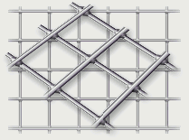 | Welded mesh is formed from perpendicular directional wires welded in cross places by step-welding method.
Material- low carbon cold drawing wire with diameter 1.2-4.0 mm of round profile and diameter 3.0-4.0mm of periodical profile.(see Chemical Composition). Parameters of welded mesh are aperture and wire diameter.
Breaking load for welding mesh from wire diameter 2.0mm and more is 295 N (min), and from wire diameter 1.4-1.6mm is 147N (min).
Welded mesh can be produced ungalvanized and hot galvanized.
Approximate weight of roll is less 500 kgs, length of roll-15-33.3m.
Welded mesh can have intermediate width and different dimensions between wire's axles.
Application:
- Fencing
- Frames for greenhouse;
- Cages for birds;
- Cages for furbearer;
- Reinforcing of concrete products
- Reinforcing of pavement.

